Bronco ID: 016590769

Last Name: Palm

First Name: Linus

# Machine Learning and Its Applications (CS 4210)

## Assignment 2

## Author: Linus Palm

## Date: 02/21/2023

Task 1:

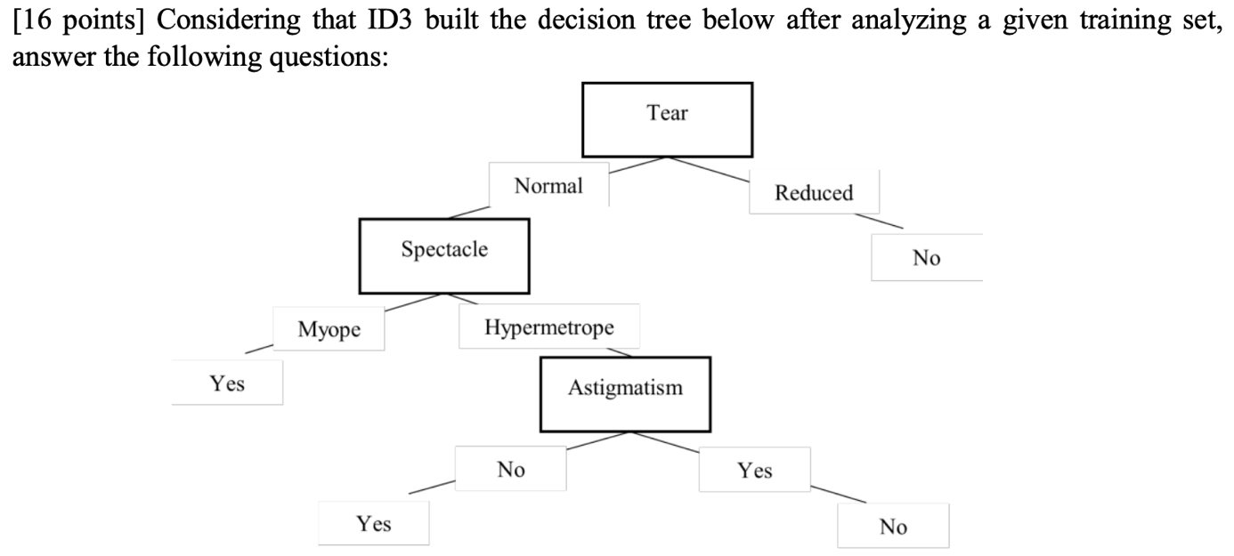

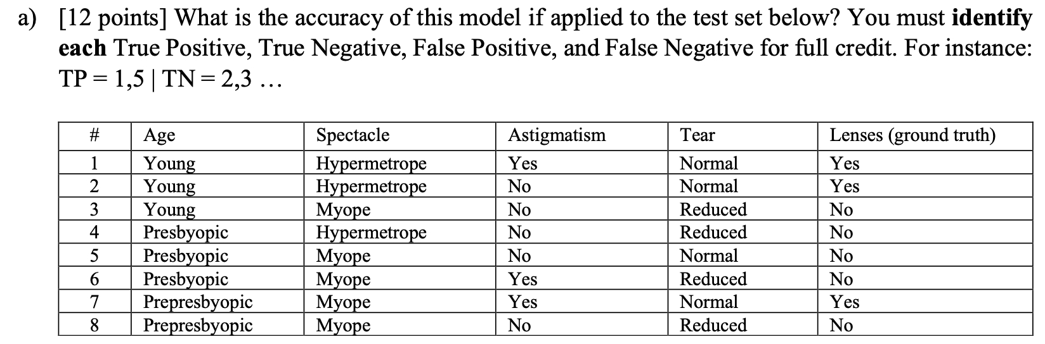

* True Positive: 2, 7
* True Negative: 3, 4, 6, 8
* False Positive: 5
* False Negative: 1



Task 2:

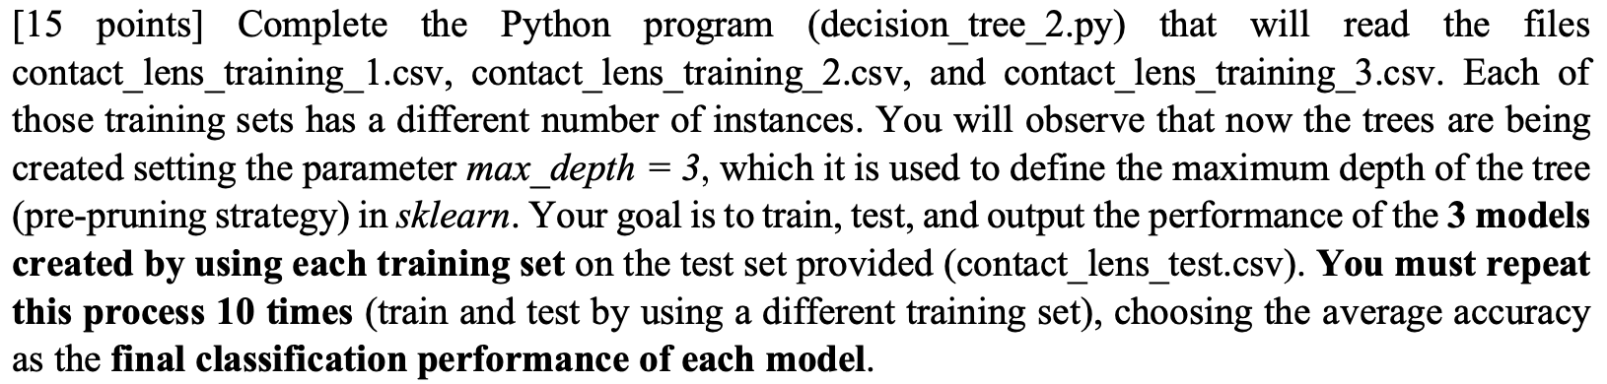

<https://github.com/LinusLinusDev/ML-Assignment-2/blob/main/decision_tree_2.py>

Task 3:

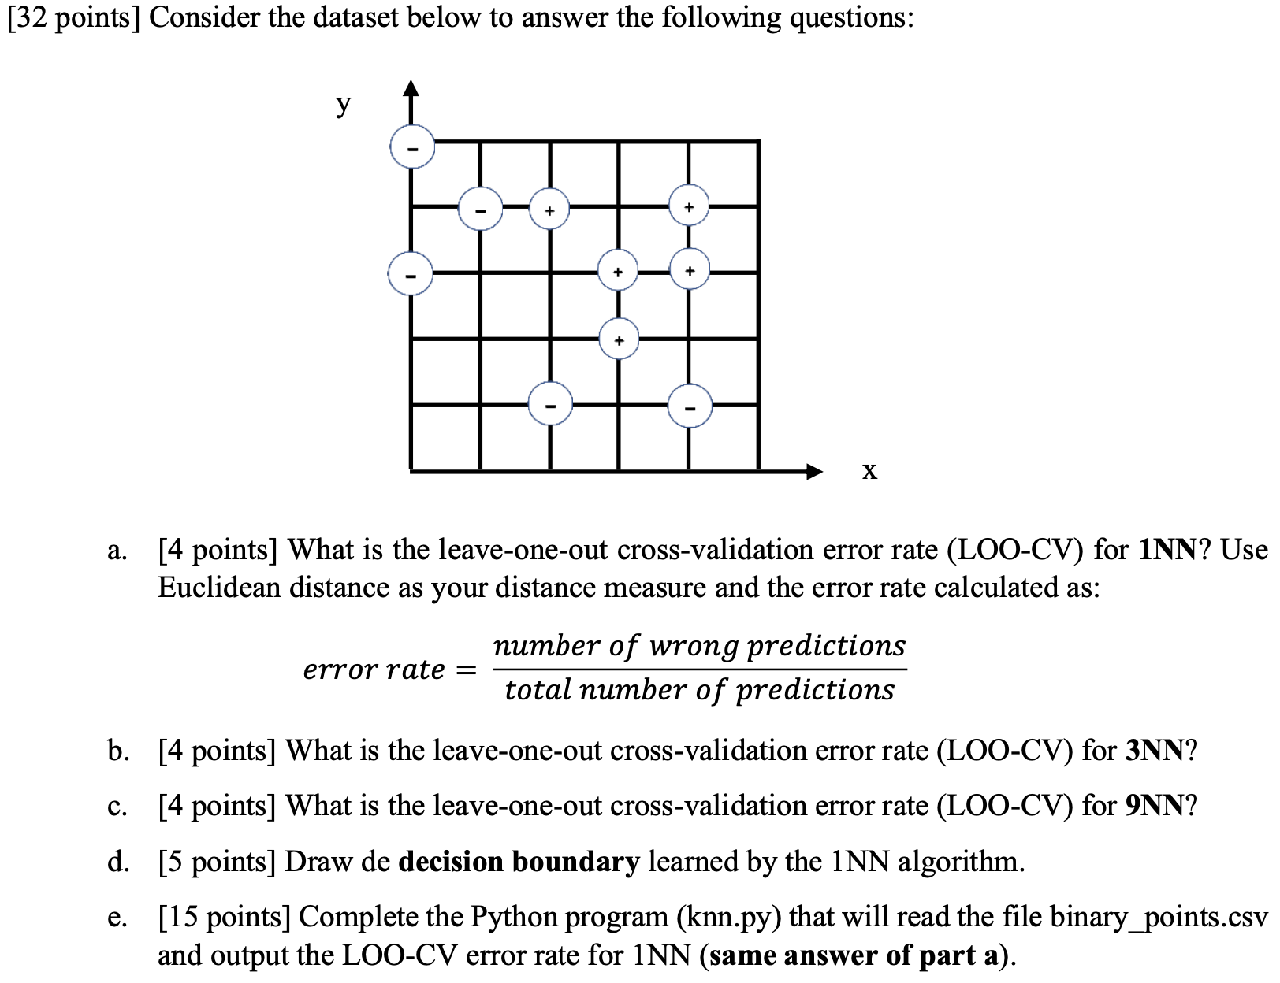

1. + b) Since the Euclidean distance is used, it is not necessary to calculate every single distance. Instead, circles can be drawn on the graph to determine the class.

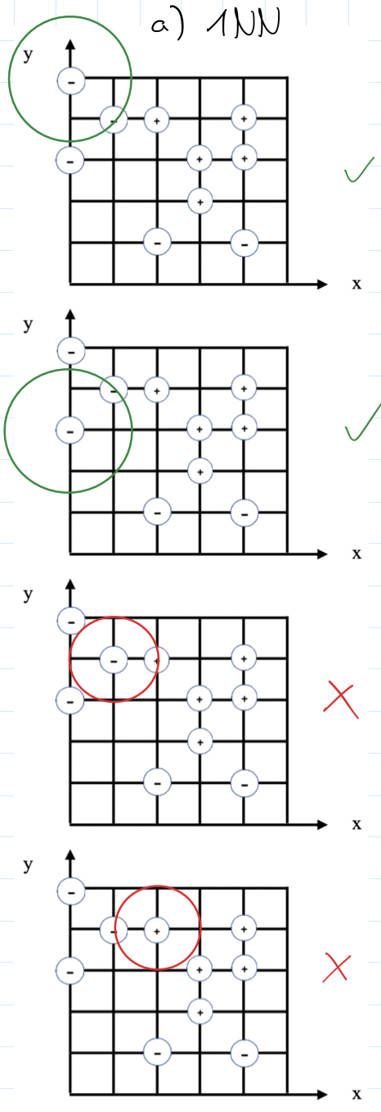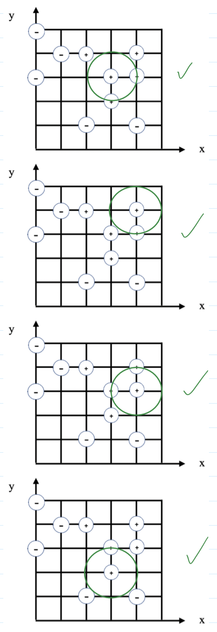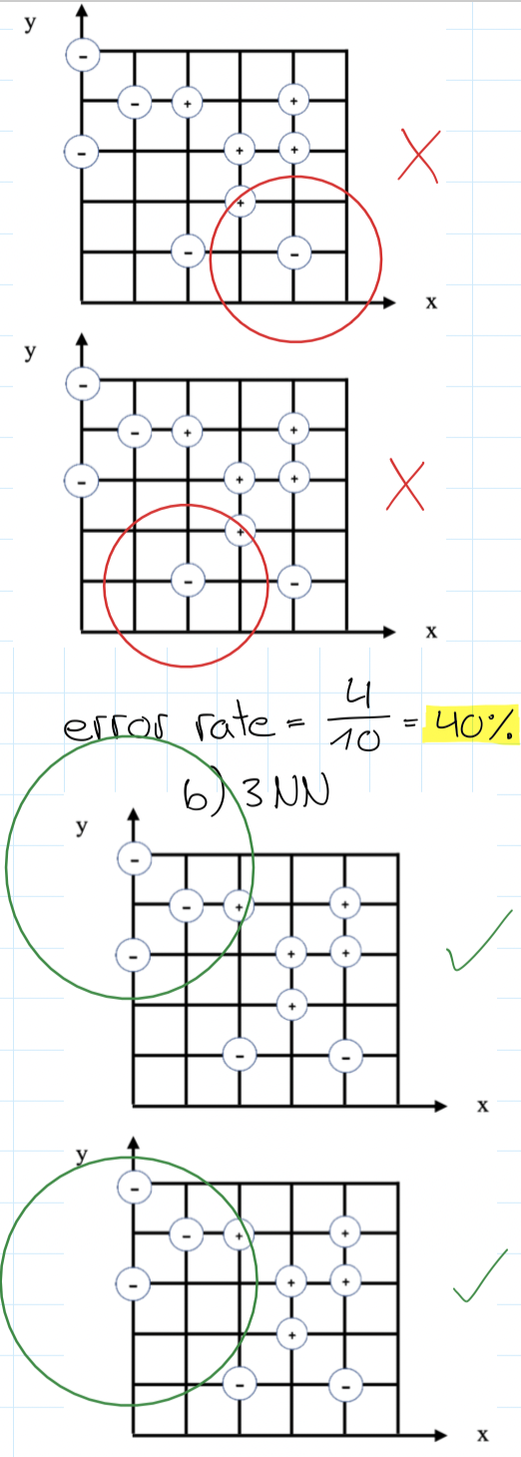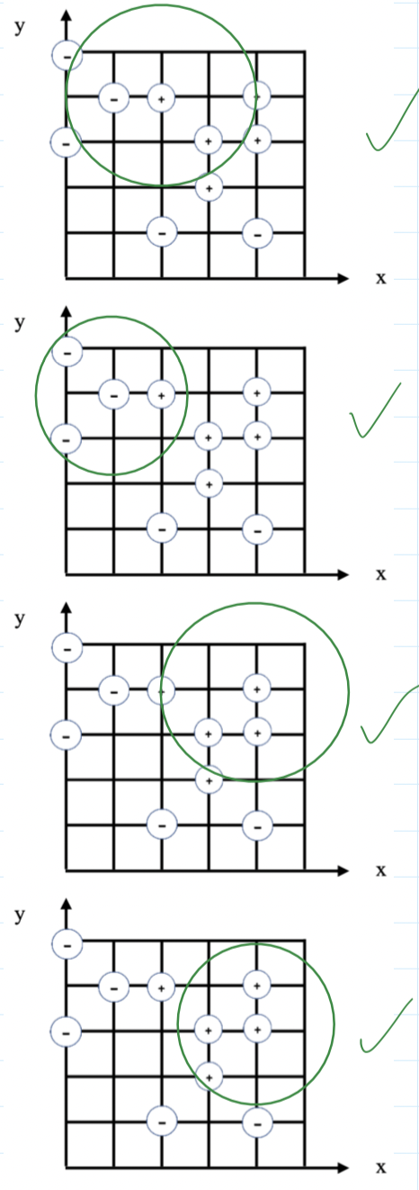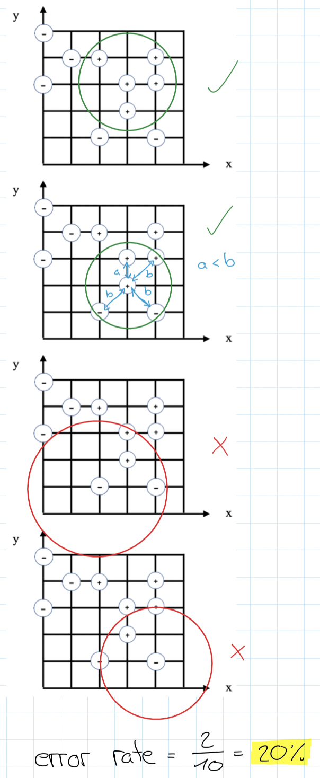

1. A total of 10 data points exist. 5 positive and 5 negative. So if you take one out and predict the class by majority vote of all the others, this prediction will always be wrong. So the error rate is 100%.

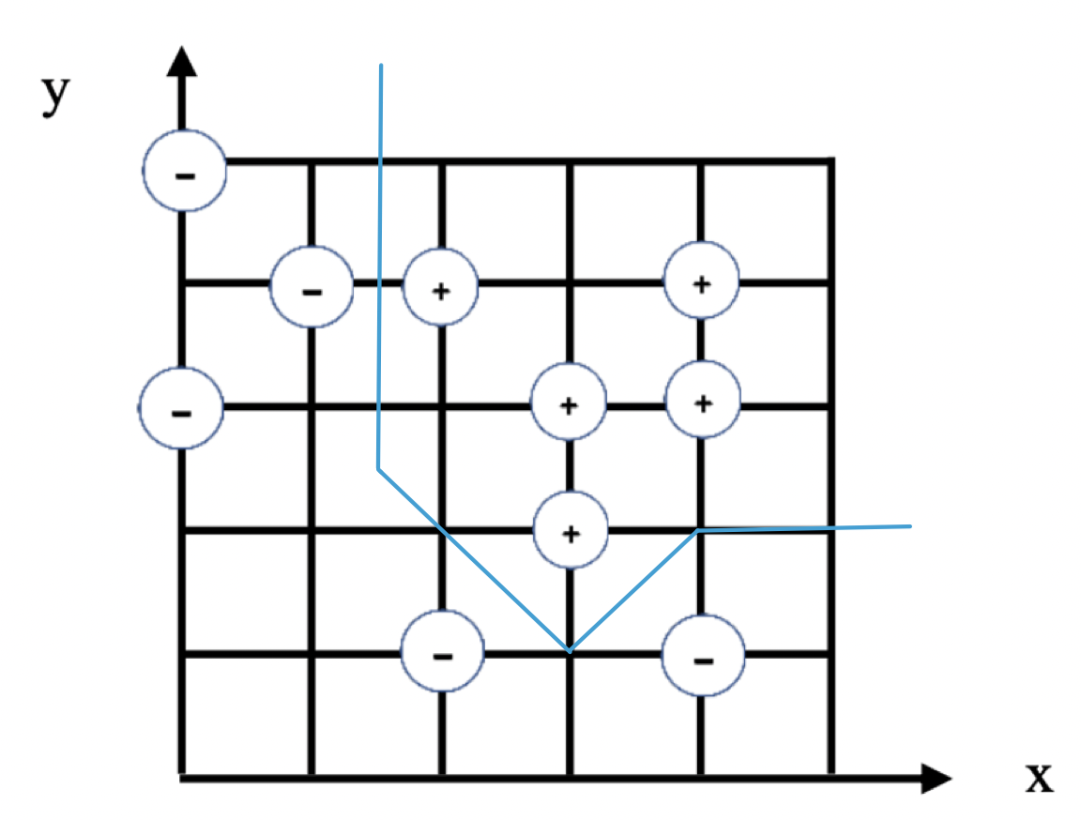

1. <https://github.com/LinusLinusDev/ML-Assignment-2/blob/main/knn.py>

Task 4:

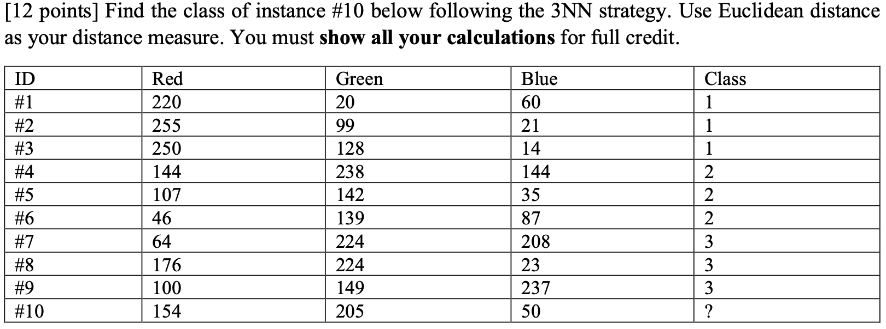

Task 5:

